**Aadim National College**

(Tribhuvan University)

Chabahil, Kathmandu

**Project Proposal**

**Nep Chat (**using state change notification algorithm)

**Faculty of Humanities and Social Science**

Tribhuvan University

Kirtipur, Nepal

**Submitted By: Submitted to:**

Name: Bikash Khanal Aadim National College

Roll No: 04 BCA Department

BCA 6th Semester

**Table of Contents**

**1.** **Introduction** 1

**2.** **Problem Statement** 1

**3.** **Objectives** 1

**4. Methodology** 2

**4.1 Requirement Identification** 2

**4.1.1 Study of existing system** 2

**4.1.2 Literature Review** 3

**4.1.3 Requirement Analysis** 4

**4.2 Feasibility Study:** 5

**4.3 High Level Design of System** 6

**4.3.1 System flow chart** 6

**4.3.2 Methodology of proposed system** 7

**4.3.3 Working mechanism of proposed system** 7

**4.3.4 Description of Algorithmns** 9

**5.Gantt Chart (Project Timeline)** 9

**6. Expected Outcomes** 10

**7. References** 10

**List of Figures**

**Figure 1: Flowchart of User** 6

**Figure 2:Waterfall Model** 7

**Figure 3:Gantt Chart** 10

# **Introduction**

Nep Chat is an innovative messaging platform designed to provide users with a secure, efficient, and feature-rich communication experience. Its simplicity and versatility make it ideal for individuals, businesses, and communities seeking seamless and secure communication. This app control over personal conversations.

By combining powerful security measures with user-centric innovations, Nep Chat redefines the messaging experience. Its simplicity and versatility make it accessible for everyday users, while its privacy-focused features offer businesses a secure platform for collaboration. Whether you need safe personal messaging, secure business discussions, or a reliable chat platform, Nep Chat provides a seamless and protected communication environment. With its focus on privacy, flexibility, and innovation, Nep Chat is setting a new standard for modern messaging platforms.

# **Problem Statement**

Without a Chat that addresses key privacy, communication, and users face several challenges. The lack of end-to-end encryption leaves sensitive information vulnerable to breaches. Users may also find it difficult to manage their chat histories, making it harder to protect private conversations.

Some of the major problems are:

* Lack of Privacy: Without strong encryption, conversations are exposed to potential data breaches.
* Connectivity Issues: Without users in areas with poor internet coverage cannot communicate.
* Risk of Data Misuse: Uncontrolled message retention increases the risk of sensitive information being misused.
* Disconnected Conversations: Poor connectivity can cause delays in sending or receiving messages, affecting real-time communication.
* Frustration Over Delays: Delays in sending messages due to poor connectivity lead to frustration and broken conversations.
* No Security Guarantees: Users may hesitate to share confidential information, fearing a lack of protection.

# **Objectives**

The main objectives of this project can be enumerated as follows:

* To create a secure and user-friendly messaging platform with flexibility for users.
* To offer innovative features such as end-to-end encryption, and users greater control over their conversations.
* To integrate features like scheduled messaging and message reminders, enabling users to plan and manage their communication effectively.
* To allow users to delete messages from both ends.

# **4. Methodology**

## **4.1 Requirement Identification**

### **4.1.1 Study of existing system**

In the current landscape, numerous chat applications exist, each offering various features catering to different user needs. Some of the most widely used messaging platforms include **WhatsApp, Telegram, Signal, and Facebook Messenger**. These applications provide real-time communication, multimedia sharing, and encryption for secure conversations. However, despite their widespread adoption, existing chat applications have several limitations and challenges.

**Limitations of Existing Chat Applications**

1. **Security and Privacy Concerns**
   * While many applications claim to offer end-to-end encryption, some still collect user metadata, which can be exploited for advertising or surveillance purposes.
   * Apps like WhatsApp and Facebook Messenger are owned by Meta, raising concerns over data privacy and security.
2. **Limited Customization and Control**
   * Most mainstream chat applications do not allow extensive customization for users.
   * Businesses and organizations may require specialized features, which are often not available in existing solutions.
3. **Dependence on Centralized Servers**
   * Many chat applications rely on centralized servers for data storage and message transmission. This poses a risk of server downtimes, hacking, and government restrictions.
   * Centralized architectures can lead to performance issues, especially in high-traffic situations.
4. **High Resource Consumption**
   * Some applications consume excessive system resources, affecting battery life and performance on mobile devices.
   * Background processes related to notifications and syncing contribute to high data usage.
5. **Limited Offline Functionality**
   * Most chat applications require an active internet connection for message transmission.
   * There are minimal solutions for offline messaging with automatic synchronization when connectivity is restored.

### **4.1.2 Literature Review**

The development of chat applications has evolved significantly, with various platforms offering real-time communication, multimedia sharing, and security features. This literature review examines key existing messaging applications, including **WeChat, Viber, WhatsApp, Telegram, and Signal**, highlighting their features, strengths, and limitations. The insights gained from these platforms help in identifying gaps that **Nep Chat** aims to address.

**1. WeChat**

**Overview:**  
WeChat, developed by Tencent, is one of the most widely used messaging applications in China. It offers text messaging, voice and video calls, social media integration, and mobile payments.

**Strengths:**

* Multi-purpose functionality integrating chat, social media, and financial transactions.
* Mini-programs that allow businesses to build services within the app.
* Strong integration with Chinese services, making it a super app.

**Limitations:**

* Concerns over privacy and government surveillance.
* Limited availability outside China due to strict regulations and restrictions.
* Heavy data consumption and resource usage.

**2. Viber**

**Overview:**  
Viber is a messaging and VoIP application known for its high-quality voice and video calls. It provides **end-to-end encryption** for private chats and group conversations.

**Strengths:**

* Secure communication with encryption for individual and group chats.
* High-quality voice and video calls.
* Public communities and chat extensions for businesses.

**Limitations:**

* Limited user base compared to competitors like WhatsApp and Telegram.
* Higher battery and data consumption in prolonged usage.
* Relies on a centralized server model, which poses privacy concerns.

**3. WhatsApp**

**Overview:**  
WhatsApp, owned by Meta, is one of the most popular messaging apps globally. It provides **instant messaging, voice calls, video calls, and media sharing** with end-to-end encryption.

**Strengths:**

* Simple and user-friendly interface.
* End-to-end encryption for private conversations.
* Widespread adoption, making it easier to connect with users worldwide.

**Limitations:**

* Owned by Meta, leading to concerns about data privacy and metadata collection.
* Limited customization options for users.
* Fully dependent on centralized servers, making it vulnerable to downtimes and cyberattacks.

**4. Telegram**

**Overview:**  
Telegram is a cloud-based messaging platform known for its **speed, large group capacities, and optional encryption** (via Secret Chats).

**Strengths:**

* Supports large groups and channels with up to **200,000 members**.
* Cloud-based architecture, allowing message access from multiple devices.
* Bot integration for automation and enhanced user experience.

**Limitations:**

* **Default chats are not end-to-end encrypted**, making them less secure.
* Requires a phone number for registration, raising privacy concerns.
* Can be blocked in certain countries due to its encryption policies.

### **4.1.3 Requirement Analysis**

Requirement analysis is done while developing a system and before implementing it, it is necessary to analyze the whole system requirement. It is categories into mainly two parts:

1. Functional requirements

2. Non-functional requirement

#### **4.1.3.1 Functional Requirement**

Login/Logout System: All users, can login/logout of the system using their unique username and password.

**User side:**

User Registration: Users can register in the system before logging in.

View Chat Features: Users can see the list of available features and settings.

Send/Receive Messages: Users can send and receive messages, including text, voice, and video.

Cancel Scheduled Messages: Users can cancel scheduled messages if needed.

Payment to prevent from scam protection and ads: Users can make payments for premium features using various payment methods like eSewa.

#### **4.1.3.2 Non-Functional Requirement**

1. Security:

* User Identification: The system requires users to identify themselves using their username and password or email.
* Login ID: Any user who uses the system must have a Login ID and Password.
* Modification: Any modifications (insert, delete, and update) to the database must be synchronized and performed only by the administrator.
* Administrator Rights: Administrators have the ability to view and modify all information within the system.

2. Maintainability:

* Back-Up: The system must provide the capability to back up data regularly.
* Availability: The system should be available and operational at all times to ensure continuous access.

## **4.2 Feasibility Study:**

Feasibility analysis is a part of system analysis carried to confirm that the system being developing is actually feasible or not. Following feasibility analysis is performed to working on the project:

Technical Feasibility: For this demo project all the tools required to build this app is freely and easily currently available. So, it is technically feasible.

Operational Feasibility: All the required operations such as internet service are available and there isn’t any legal issue. So, this project can be considered operationally feasible.

Economic Feasibility: This project is developed using software selling kits of which all are open source, so it does not incur any costs. Hence, this project is economically feasible and can be implemented easily.

## **4.3 High Level Design of System**

### **4.3.1 System flow chart**

1. User

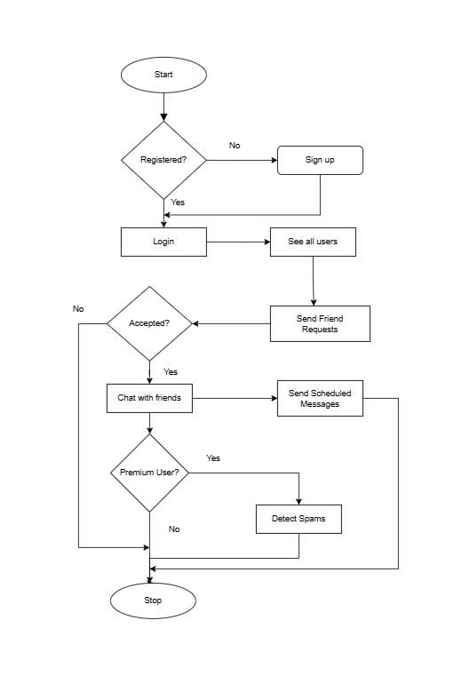

**Figure 1: Flowchart of User**

### **4.3.2 Methodology of proposed system**

The commonly used methodologies include agile development methodology, waterfall method and rapid application development. There are few other methodologies depending upon the nature and objective of the software.

In developing entire system, I will be using the Waterfall Development Model. This is the most suitable model for our system. In addition, this model is very simple and easy to understand then others model. It is easy to manage and arrange tasks. Each phase must be completed before the new phase start, so there is no overlapping in the phases. The following illustration is a representation of different phases of the waterfall model:

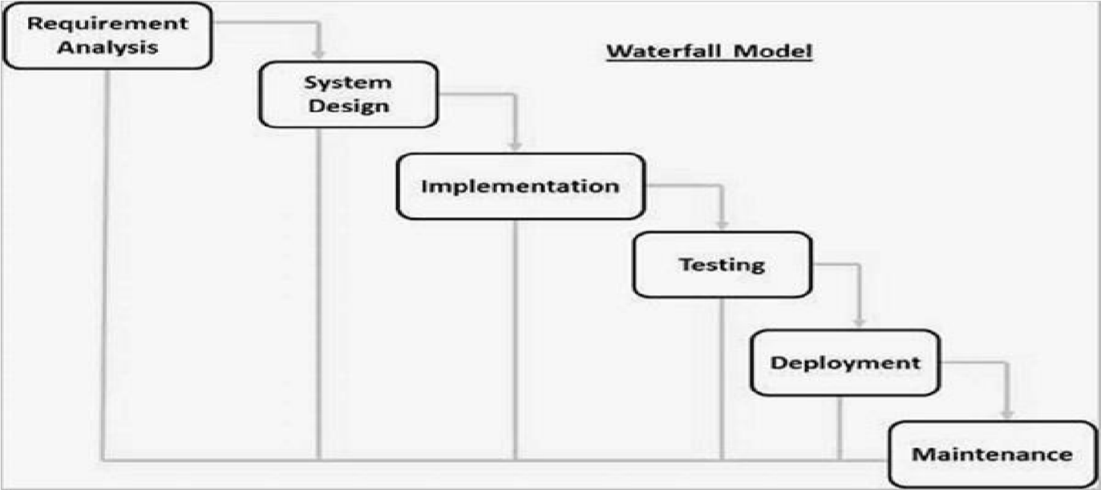

**Figure 2:Waterfall Model**

### **4.3.3 Working mechanism of proposed system**

Nep Chat works as a secure and efficient messaging platform designed with advanced encryption and privacy features. Here's a breakdown of how it might work:

1. **User Registration and Authentication**

* **User Signup**: New users create an account by providing basic information like name, email, and password. They might also need to verify their identity via email or mobile OTP.
* **Authentication**: After registration, users authenticate by logging in with their credentials. Nep Chat could use a combination of JWT (JSON Web Tokens) and sessions to maintain secure login states.

2. **End-to-End Encryption**

* **Message Encryption**: All messages are encrypted using strong encryption algorithms, ensuring that only the sender and the recipient can read the messages. Even if the data is intercepted while in transit, it cannot be read without the decryption key.

3. **Real-Time Communication**

* **WebSocket for Instant Messaging**: Nep Chat uses WebSocket or another real-time communication protocol to enable instant messaging between users. This allows messages to be sent and received without delays.

4. **Media Sharing and Encryption**

* **Secure Media Transfer**: Users can send photos, videos, and other media securely, where the files are encrypted during transfer and stored encrypted on the server or in a decentralized file system like IPFS (InterPlanetary File System).

**4. Scheduled Messaging**

* **How it Works**: Users can compose a message and **schedule it** to be sent at a later time.
* **Use Cases**:
  + Send **reminders** for meetings or birthdays.
  + Schedule messages for **different time zones**.
  + Automate **greetings and updates**.
* **Security**: Scheduled messages remain **encrypted** and are stored securely on the user's device/server until they are sent.

**7. Spam Detection for Premium Users**

* **AI-Powered Spam Detection**: Premium users get access to an advanced spam detection system.
* **How It Works**:
  + Uses **AI and pattern recognition** to **detect spam** in messages.
  + Automatically filters **scam links, bulk messages, and phishing attempts**.
  + Notifies users if a message looks suspicious.
* **User Control**: Premium users can **customize spam filtering** sensitivity or disable it.

In essence, Nep Chat is built on the premise of maintaining security, privacy, and control for its users while offering an intuitive and efficient messaging experience.

### **4.3.4 Description of Algorithmns**

1.Typing Indicator Algorithm

* Algorithm Name: State Change Notification Algorithm
* Description: This algorithm is used to notify users when someone is typing a message. It involves detecting changes in the user's state (from "idle" to "typing") and sending real-time updates to other users in the conversation.

Working: When a user starts typing, the client triggers a state change, which is sent to the server via a WebSocket or polling mechanism. The server then broadcasts this state change to other connected clients, indicating that a particular user is typing.

2. Message Scheduling Algorithm

* Algorithm Name: Time-Based Scheduling Algorithm (Cron Scheduling)
* Description: The Time-Based Scheduling Algorithm, also known as Cron Scheduling, is used to schedule messages to be sent at specific times. The algorithm stores the message along with the scheduled time, and a background process continuously checks for messages that need to be sent at the current time.

Working:

* The user specifies the time for the message to be sent (e.g., "send this message at 3 PM tomorrow").
* The system stores the scheduled message and its timestamp.
* At regular intervals, the system checks if the current time matches the timestamp of any scheduled message.
* When a match occurs, the message is sent, and the schedule is cleared.

Use Case: This algorithm is used to schedule messages for future delivery at specific times, such as reminders or notifications.

# **5.Gantt Chart (Project Timeline)**

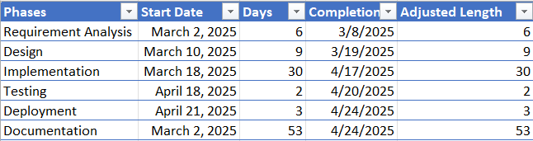

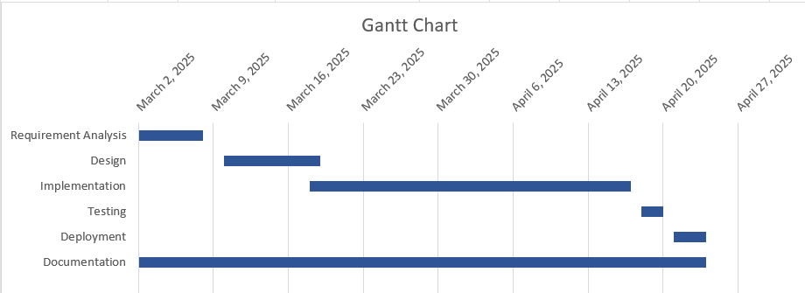

**Figure 3:Gantt Chart**

# **6. Expected Outcomes**

Nep Chat is expected to deliver a **secure, efficient, and user-friendly messaging experience** with features like **end-to-end encryption, scheduled messaging, and AI-powered spam detection** for premium users. By ensuring **privacy-first communication**, users can confidently send messages and media without security concerns. The **real-time messaging system** enhances engagement, while **scheduled messages** improve convenience. Premium features like **spam filtering and expanded storage** add value, encouraging user retention and subscription growth. With **scalable architecture and future AI-driven enhancements**, Nep Chat is set to become a **trusted and innovative messaging platform** for personal and professional communication.

# **7. References**

[1] WeChat - 全球10億用戶選擇的聊天通話應用程式,” Wechat.com, 2019. https://www.wechat.com/

[2]“Home,” Viber. https://www.viber.com/en/

‌

‌

‌